**Digital Nurture 4.0 Week 7**

**REACT**

**ADDITIONAL EXERCISES**

**File name: 13. ReactJS-HOL**

**Step 1: Create the React App**

npx create-react-app bloggerapp

cd bloggerapp

npm start

**Step 2: BookDetails.js**

import React from 'react';

function BookDetails({ books }) {

return (

<div>

<h2>📚 Book Details</h2>

<ul>

{books.map((book, index) => (

<li key={index}>

<strong>{book.title}</strong> - {book.author}

</li>

))}

</ul>

</div>

);

}

export default BookDetails;

**Step 3: BlogDetails.js**

import React from 'react';

function BlogDetails({ blogs }) {

return (

<div>

<h2>📝 Blog Details</h2>

{blogs.length === 0 ? (

<p>No blogs available.</p>

) : (

blogs.map((blog) => (

<div key={blog.id} style={{ marginBottom: '10px' }}>

<h4>{blog.title}</h4>

<p>{blog.content}</p>

</div>

))

)}

</div>

);

}

export default BlogDetails;

**Step 4: CourseDetails.js**

import React from 'react';

function CourseDetails({ courses }) {

if (!courses || courses.length === 0) return null; // Prevent rendering

return (

<div>

<h2>🎓 Course Details</h2>

<ul>

{courses.map((course, index) => (

<li key={index}>

<b>{course.name}</b> - Duration: {course.duration}

</li>

))}

</ul>

</div>

);

}

export default CourseDetails;

**Step 5: App.js**

import React, { useState } from 'react';

import BookDetails from './components/BookDetails';

import BlogDetails from './components/BlogDetails';

import CourseDetails from './components/CourseDetails';

function App() {

const [section, setSection] = useState('books');

const books = [

{ title: 'React in Action', author: 'Mark T.' },

{ title: 'Learning React', author: 'Alex B.' }

];

const blogs = [

{ id: 1, title: 'React Basics', content: 'Learn JSX, components, props...' },

{ id: 2, title: 'Hooks in Depth', content: 'Explore useState, useEffect...' }

];

const courses = [

{ name: 'ReactJS', duration: '6 weeks' },

{ name: 'JavaScript Advanced', duration: '4 weeks' }

];

const renderSection = () => {

switch (section) {

case 'books':

return <BookDetails books={books} />;

case 'blogs':

return <BlogDetails blogs={blogs} />;

case 'courses':

return <CourseDetails courses={courses} />;

default:

return <p>Please select a section.</p>;

}

};

return (

<div className="App" style={{ padding: '20px' }}>

<h1>🧠 Blogger App</h1>

{/* Conditional Buttons */}

<button onClick={() => setSection('books')}>Show Books</button>

<button onClick={() => setSection('blogs')}>Show Blogs</button>

<button onClick={() => setSection('courses')}>Show Courses</button>

<hr />

{/* Element Variable with Conditional Rendering */}

{renderSection()}

{/* Inline Ternary Example */}

<p style={{ marginTop: '20px', fontStyle: 'italic' }}>

{section === 'books'

? 'Reading is essential for growth.'

: section === 'blogs'

? 'Keep blogging, keep learning!'

: 'Enroll in a course to upskill yourself.'}

</p>

</div>

);

}

export default App;

**Output:**

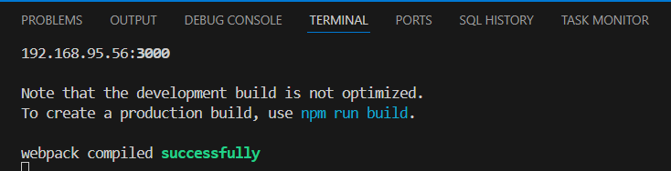

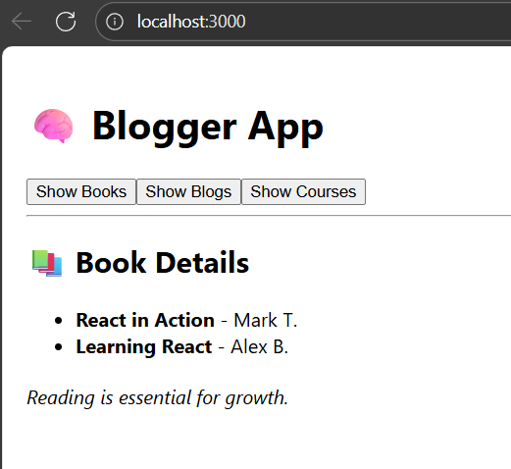

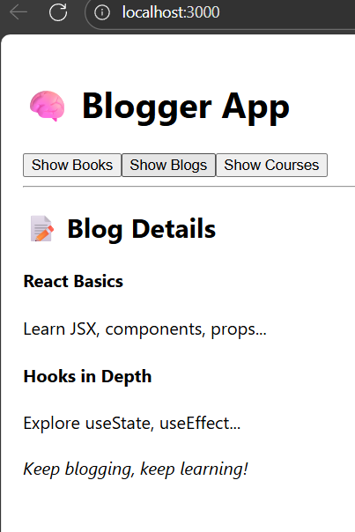

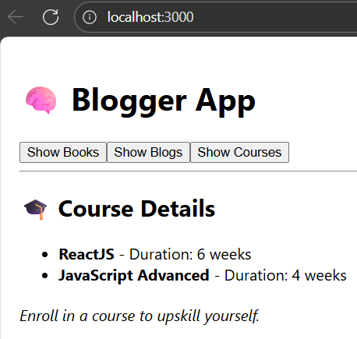

**File name: 14. ReactJS-HOL**

1. **Create the app**

npx create-react-app employee-management-app

cd employee-management-app

npm start

**2.ThemeContext.js**

import React from 'react';

const ThemeContext = React.createContext('light');

export default ThemeContext;

**3.App.js**

import React, { useState } from 'react';

import EmployeesList from './EmployeesList';

import ThemeContext from './ThemeContext';

import './App.css';

function App() {

const [theme, setTheme] = useState('light');

const toggleTheme = () => {

setTheme(theme === 'light' ? 'dark' : 'light');

};

return (

<ThemeContext.Provider value={theme}>

<div className={`app-container ${theme}`}>

<h1>👩‍💼 Employee Management</h1>

<button className={`btn btn-${theme}`} onClick={toggleTheme}>

Toggle Theme

</button>

<EmployeesList />

</div>

</ThemeContext.Provider>

);

}

export default App;

4. EmployeesList.js

import React from 'react';

import EmployeeCard from './EmployeeCard';

function EmployeesList() {

const employees = [

{ id: 1, name: 'Saranya Devi', role: 'Frontend Developer' },

{ id: 2, name: 'Naveen Kumar', role: 'Backend Developer' },

{ id: 3, name: 'Priya S', role: 'UI/UX Designer' }

];

return (

<div>

<h2>Employee List</h2>

{employees.map((emp) => (

<EmployeeCard key={emp.id} employee={emp} />

))}

</div>

);

}

export default EmployeesList;

5. EmployeeCard.js

import React, { useContext } from 'react';

import ThemeContext from './ThemeContext';

function EmployeeCard({ employee }) {

const theme = useContext(ThemeContext);

return (

<div className={`card card-${theme}`}>

<h3>{employee.name}</h3>

<p>{employee.role}</p>

<button className={`btn btn-${theme}`}>View Profile</button>

</div>

);

}

export default EmployeeCard;

**6.** **App.css**

.app-container {

font-family: Arial, sans-serif;

padding: 20px;

}

.card-light {

background-color: #f0f0f0;

color: #000;

border: 1px solid #ccc;

padding: 15px;

margin: 10px 0;

border-radius: 8px;

}

.btn-light {

background-color: #ddd;

color: #000;

padding: 8px 12px;

border: none;

border-radius: 4px;

cursor: pointer;

}

.card-dark {

background-color: #2b2b2b;

color: #fff;

border: 1px solid #555;

padding: 15px;

margin: 10px 0;

border-radius: 8px;

}

.btn-dark {

background-color: #444;

color: #fff;

padding: 8px 12px;

border: none;

border-radius: 4px;

cursor: pointer;

}

/* Extra */

.btn {

margin-bottom: 20px;

}

**Output:**